Accessing Coast Title Fees within LendingQB
- From the Main Screen, select “LodeStar” for the desired file you would like to run a quote.
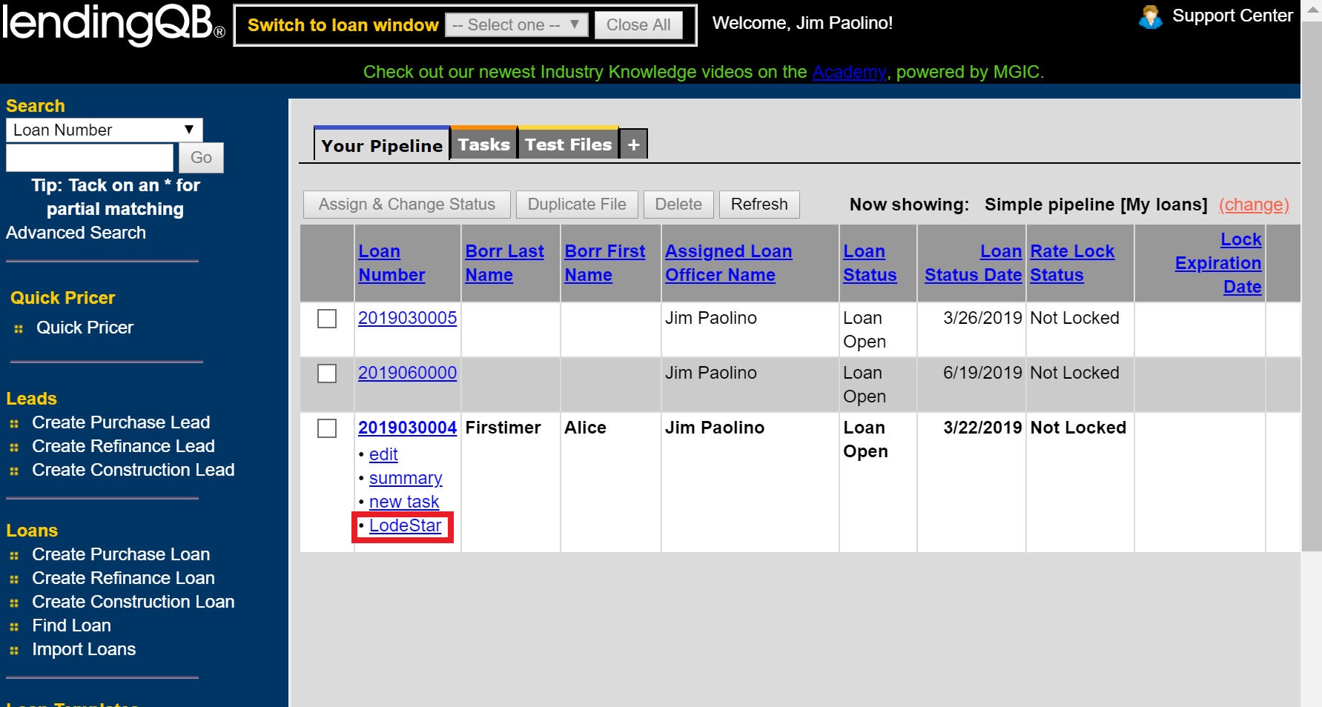

- This LodeStar calculator screen will open and import the fees for your given transaction. Fill in any remaining questions and click “Calculate”

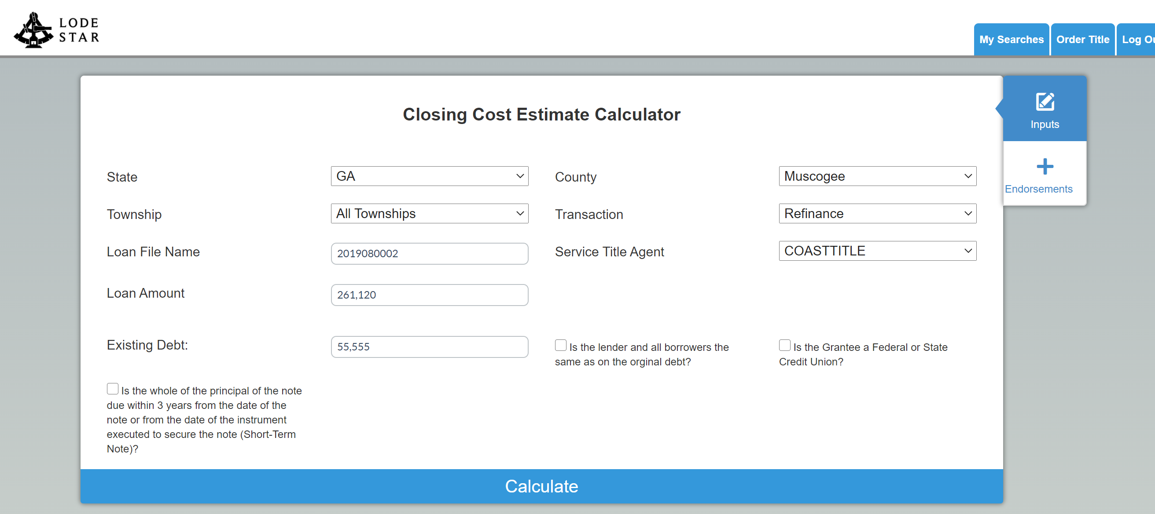

- The closing costs for the given transaction will be returned. Select “Export to LendingQB” to push these into the LOS.

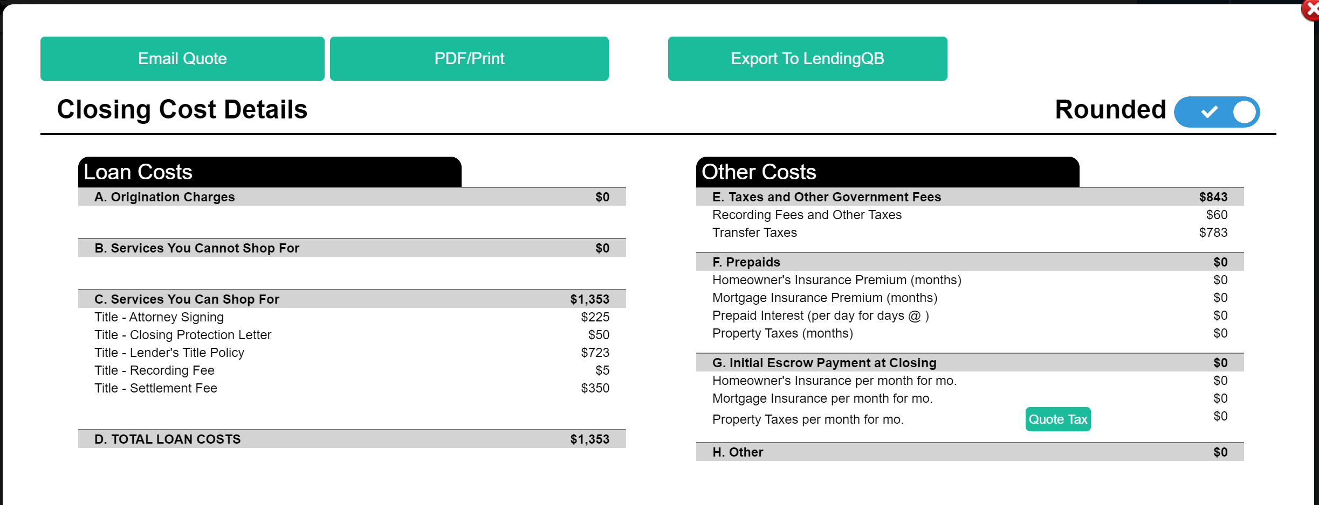

- The fees will now be displayed on the “Disclosures TRID/Borrower-responsible Closing Costs” tab.

